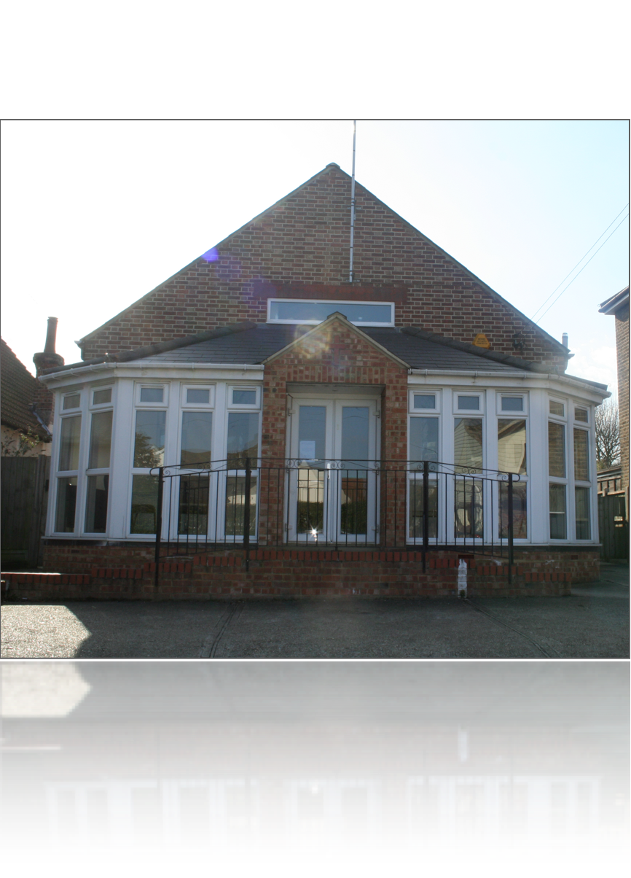

ANNOUNCEMENTS
Everyone is welcome to stay for fellowship lunch today.
FRIDAY VESPERS
Time: 7.00pm Venue: 17 Jersey Gardens
CHURCH EXCURSION - 25 August 2013
The proposed venue for our Church Excursion is Dove Dale in the Peak District. Alternatively, we can visit the Epping Forest area or the Maldon Area.
Should you have any further venue ideas please speak to Bro Tyronne. We must finalise a venue in the coming week or two.
CHOIR PRACTICE
Wednesday at 8.00pm at Church.
SCHOOL OF EVANGELISM
22 September to 15 June 2013/14
Please see the website for more information on Health Ministries courses and the SEC Evangelism Course, and to obtain an application form.
PRAYER MINISTRIES DEPARTMENT
The Intercessory Prayer Group will meet on Tuesday at 7.00pm at Sis Salisha's house.
Prayer Retreat – 9-11 August 2013
Please see Sis Salisha for further information.
Please send your announcements to Marlene by Wednesday.

WELCOME
ONE AND ALL TO
Basildon District

D
SEVENTH-DAY ADVENTIST CHURCH
Sabbath 27th July 2013
Address:
17 Jersey Gardens,
Wickford SS11 7AG
More Info
www.basildonsdachurch.org.uk
communication@basildonsdachurch.org.uk
† Services ¢
Sabbath School: 09:30a.m.
Divine Service: 11:15a.m.
AYS/Bible Study: 3;00p.m.
Church and Christ
Pastor John Melki

Pastor  Head Elder | J. Melki  T. Waldron | 07803829790  07956067485
Elders | E. Oluikpe  O. Skerritt | 07896565913  07956876153
Personal Mins  Head Deacon  Head Deaconess  Church Clerk  Sabbath School  Children’ Mins  Youth  Music Director  Media  Women’s Mins  Men’s Mins  AMR  Pathfinders  Interest Co-  Prayer Ministry  Stewardship  Communications  CSR  Community Serv.  Health Ministry  Prision Ministry | P. Mbano  J. Jackman  L. Chikwanha  M. Skerritt  A. Oluikpe  G. Harrison  J. Jackman  O. Skerritt  O. Skerritt  I. Charidza  E. Oluikpe  S. Jackman  K. Waldron  E. Babafemi  S. Jackman  E. Oluikpe  M. Skerritt  P. Mangena  M. Sabadin  N. Nhliziyo  V. Jere | 07809151964  07951770754  07429693007  07771535999  07546968476  01268530191  07951770754  07956876153  07956876153  07957482603  07896565913  07853029696  07904197510  07535351666  07853029696  07896565913  07956876153  07707041832  07966293791  07931226320  07887503133

Church and Christ
Introit
Father we love you, we worship and adore you,
Glorify thy name in all the earth,
Glorify thy name, glorify thy name,
Glorify thy name in all the earth.
Hymn No. 694
Praise God from whom all blessings flow,
Praise Him all creatures here below,
Praise Him above, ye heavenly host,
Praise Father, Son, and Holy Ghost.
Hymn No. 684
Hear our prayer, O Lord,
Hear our prayer, O Lord,
Incline Thine ear to us,
And grant us Thy peace. Amen.
Let There be Love Shared Among Us.
Let there be love shared among us,
Let there be love in our eyes,
May now your love sweep this nation,
Cause us O Lord to arise.
Give us a fresh Understanding
Of brotherly love that is real,
Let there be love shared among us,
Let there be love.
Call To Worship
L: The LORD is my light and my salvation; whom shall I fear?
P: The LORD is the stronghold of my life; of whom shall I be afraid?
L: One thing I asked of the LORD, that will I seek after:
P: To behold the beauty of the LORD, and to inquire in his temple.
L: "Come," my heart says, "seek his face!"
P: Your face, LORD, do I seek.
L: O Lord God of our salvation, we worship and adore you,
P: We will sing your praises for ever and ever. Amen!
Divine Service
Announcements: Sis. Marlene Skerritt
Call to worship: Eld. Emeka Oluikpe
Introit: Father we love You
Invocation: Pastor John Melki
Doxology: Hymn 694
Welcome: Eld. Emeka Oluikpe
Opening Hymn: Eld. Emeka Oluikpe
100: Great is Thy faithfulness
Scripture reading: John 2:13-17
Children’s story: Sis. Odessa Cooper
Tithes and Offerings: Bro.Munya Muchirahondo
Garden of Prayer: Sis. Abiola Oluikpe
Prayer Response: Hymn 684
Praise and Worship: Praise Team
Special Item: Basildon Church Choir
Sermon: Pastor John Melki
“Church and Christ?”
Closing Hymn: Eld. Emeka Oluikpe
306 – Draw me nearer blessed Lord
Benediction: Pastor John Melki
Postlude: Let there be love…

